1.Hadooop Map Reduce Algorithm:

Implement MapReduce algorithm for finding Facebook common Friends problem and run the MapReduce job on Apache Hadoop. Write a report including your algorithm and result.

Facebook Mutual Friends:

The Map Reduce job running on Hadoop. The jar file extracted from IntelliJ Maven is kept in the source folder. The input is placed in source folder.

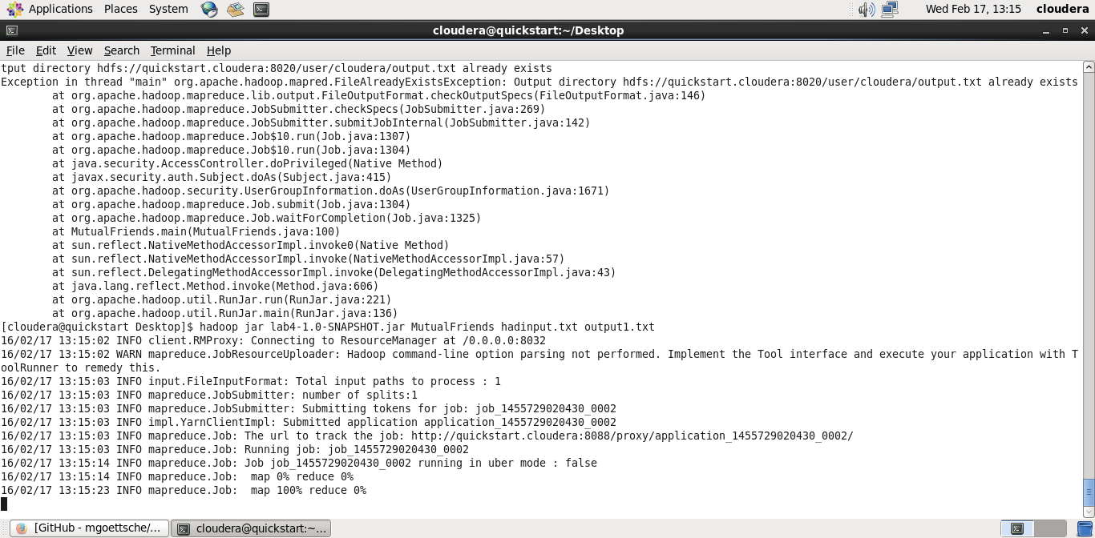



The output looks as below:

It is showing the mutual friends.



**2. Android Studio Speech to text conversion:**

Smartphone/Watch Application:- Implement a smartwatch/smartphone application using existing speech services/image services (e.g., IBM Alchemyapi, Face++) related to your project.

The speech is converted into text and displayed. We have used Android Speech to Text API for this application.

